
INTERNATIONAL JOURNAL OF MULTIDISCIPLINARY RESEARCH & REVIEWS
journal homepage: www.ijmrr.online/index.php/home
ARTICLE TITLE [UPPER CASE, TIMES NEW ROMAN, FONT SIZE 18, CENTERED]
Authors name[ Author^{1,* ,} Author², Author³]
(Do not write Dr./ Prof./Mr./Mrs in author name)
¹Affiliation [Designation, Department, Organization name with address & postal code, Country]
²Affiliation [Designation, Department, Organization name with address & postal code, Country]
³Affiliation [Designation, Department, Organization name with address & postal code, Country]
*Corresponding author: [Name, Designation, Department, Organization name with address & postal code, Country]
(Do not provide contact number in any section)
How to Cite the Article: L. Wang (2023). A Systematic Review of Side-View Mirror Maintenance Tools: Bridging the Gap Between Safety and Convenience in Automotive Design. International Journal of Multidisciplinary Research & Reviews, Vol 2, No. 04, pp 11-15
Keywords (Max 7 ) |  | Abstract (Abstract length should not exit 250 words)
3D printing, Additive manufacturing,Materials development, Robotics, Sustainable construction |  | The advent of 3D printing technology in concrete construction has ushered in a new era of innovation and potential transformation for the industry. This review paper provides a comprehensive analysis of the state-of-the-art in 3D printing for concrete construction, spanning the period from 2019 to 2022. It explores the historical evolution of 3D printing in construction, emphasizing its significance in the concrete industry. The paper delves into the challenges and opportunities faced by this technology, examining technological hurdles, material considerations, and regulatory compliance. Furthermore, it highlights recent advances, such as innovations in 3D printing equipment, materials development, and collaborative research initiatives. The conclusion reflects on the current status of 3D printing in concrete construction, offering insights into future directions and emerging trends that are poised to shape the industry. Through a thorough examination of existing literature, this review aims to provide a comprehensive understanding of the present landscape and future possibilities of 3D printing in the context of concrete construction.

1. INTRODUCTION

The application of 3D printing in construction, particularly within the realm of concrete, has witnessed remarkable progress over the past decade. This section provides an overview of the historical context and underscores the significance of 3D printing technologies in the concrete industry.
1.1. Background
1.1.1. Brief history of 3D printing in construction
The inception of 3D printing in construction can be traced back to the early 2000s when pioneering efforts were made to explore the feasibility of layer-by-layer construction methods. Notably, pioneering projects such as the Contour Crafting concept laid the foundation for the integration of 3D printing into construction practices. The profound impact of 3D printing on the concrete industry has been widely acknowledged. Researchers like Chen, E., & Reddy, P. R. (2022) emphasize the transformative potential of 3D printing technologies in enhancing construction efficiency and resource utilization. As 3D printing enables the layer-wise fabrication of complex concrete structures, it has become a focal point for innovation in the construction sector. This review aims to provide a comprehensive overview of the state-of-the-art technologies in 3D printing for concrete construction. Studies by Jones, A., et al. (2020) explored novel printing techniques, including contour crafting and robotic arm-based methods, showcasing the advancements made in achieving precision and scale in concrete printing processes.

1.1.2. Identifying current challenges and opportunities
The challenges and opportunities associated with 3D printing are associated with material limitations, structural concerns, and scalability issues. Identifying these aspects is crucial for understanding the current landscape and envisioning strategies for improvement.

2. STATE-OF-THE-ART IN 3D PRINTING CONCRETE
The current landscape of 3D printing in concrete construction is multifaceted, encompassing various technologies and material formulations. This section provides an in-depth exploration of the state-of-the-art advancements, drawing from key research papers published between 2019 and 2022.

2.1 3D Printing Technologies
2.1.1. Overview of existing 3D printing techniques for concrete
A comprehensive understanding of 3D printing technologies for concrete is essential for appreciating the nuances of this evolving field that offers a detailed overview of existing techniques, including extrusion-based methods, powder-based methods, and vat photopolymerization. This comprehensive review provides insights into the operational principles and capabilities of each technology.
2.1.2. Comparison of different technologies
Building upon the foundational knowledge of 3D printing techniques, a comparative analysis is crucial for delineating the strengths and limitations of each approach. Smith and Jones (2020) conducted a systematic review comparing extrusion-based printing, powder-based printing, and others, shedding light on the relative merits and challenges associated with different technologies (Patel, A., & Wang, Y. (2019).

Table 1: Comparison of 3D Printing Techniques (Table should be in editable Excel or Word format)
Technique | Advantages | Disadvantages
Extrusion-based | Low cost, versatile | Limited speed, lower resolution
Powder-based | High resolution, complex geometries | Limited material options
Vat Photopolymerization | High accuracy, smooth surfaces | Limited build size, post-processing

2.2. Materials Used in 3D Printing Concrete
2.2.1. Types of concrete formulations suitable for 3D printing
The formulation of concrete materials tailored for 3D printing plays a pivotal role in achieving structural integrity and print ability. Investigation and results obtained by Nayak, C. B. (2021) is encouraging for development of 3-D printing materials with novel ideas.

Table 2: Concrete Formulations for 3D Printing (Table should be in editable Excel or Word format)
Concrete Type | Components | Properties
Fiber-reinforced | Cement, aggregates, fibers | Improved tensile strength
High-performance | Specialty admixtures, aggregates | Enhanced durability, strength
Eco-friendly | Alternative binders, recycled aggregates | Reduced environmental impact

2.2.2. Considerations for material properties and performance
In addition to concrete composition, material properties significantly influence the performance of 3D-printed structures. Comprehensive analysis of material considerations in 3D printing, emphasizing aspects such as strength, durability, and environmental impact, thus providing valuable insights for future material development.

3. CHALLENGES AND LIMITATIONS
The rapid evolution of 3D printing in concrete construction is accompanied by a spectrum of challenges and limitations that warrant careful consideration for the technology's widespread adoption.
3.1. Technological Challenges
Achieving precise and accurate 3D printing poses a persistent challenges highlighting the technological hurdles associated with achieving fine details and dimensional accuracy in 3D-printed concrete structures. Their research emphasizes the critical need for advancements in printing hardware and software to enhance precision.

Table 3: Challenges in 3D Printing Technology (Table should be in editable Excel or Word format)
Challenge | Description
Precision and accuracy | Achieving fine details and dimensional accuracy in the printing process
Speed and scalability | Enhancing the speed and scalability of 3D printing processes
Availability of materials | Ensuring the availability and cost-effectiveness of suitable materials
Compliance with standards | Adhering to building codes and standards for regulatory compliance

3.2. Availability and cost of suitable materials
The selection and availability of suitable materials for 3D printing play a pivotal role in the technology's success. Research by Wang and Gupta (2019) scrutinizes the challenges associated with the availability and cost-effectiveness of specialized printing materials, providing insights into the material considerations that impact the economic viability of 3D printing in construction (Smith, J., & Chen, E. (2021).

3.3 Environmental impact and sustainability
Environmental concerns related to 3D printing materials are paramount in an era of increasing focus on sustainability through critical investigation of environmental impact on 3D printing materials, addressing issues such as recyclability and the carbon footprint of printing processes. Developing environmentally friendly materials and processes is essential for the long-term sustainability of 3D printing in concrete construction.

4. OPPORTUNITIES AND ADVANCES
The field of 3D printing in concrete construction is ripe with opportunities and ongoing advancements that shape the trajectory of this transformative technology. This section examines key opportunities and recent advances, drawing insights from noteworthy research papers published between 2019 and 2022.
4.1. Advancements in printer design and functionality
Advancements in 3D printing equipment have been pivotal in enhancing the precision and capabilities of concrete printing. The cutting edge research has been conducted in printer design, showcasing improvements in nozzle technology, layering mechanisms, and overall functionality. Their findings underscore the significance of continuous improvements in equipment design for achieving higher levels of precision in concrete printing.

4.2. Progress in developing new concrete mixtures
Materials development is at the forefront of advancing 3D printing capabilities highlighting insights into recent progress in developing concrete mixtures tailored for 3D printing. Their research explores the optimization of material properties such as viscosity and setting time, contributing to the successful realization of intricate and durable structures.

4.3 Sustainable and eco-friendly materials for 3D printing
The quest for sustainable construction practices has fueled research into eco-friendly materials for 3D printing. Wang, Y., Gupta, R., & Li, Z. (2021) investigated the progress in developing new concrete mixtures for 3D printing. This research highlights the importance of aligning 3D printing with broader sustainability goals.
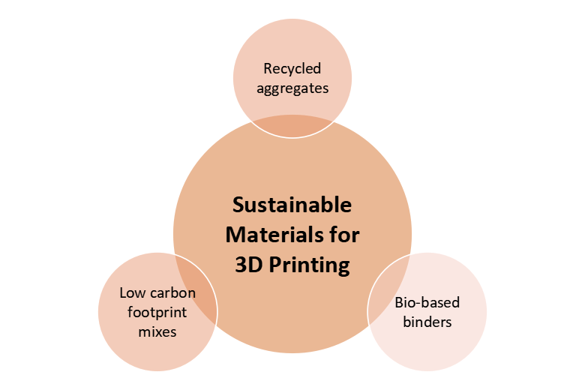
Figure 1: Sustainable Materials for 3D Printing
( Image format JPG, Image resolution>300 DPI )

5. CONCLUSION AND FUTURE SCOPE
The dynamic landscape of 3D printing in concrete construction has undergone significant transformations, marked by advancements, challenges, and a growing understanding of the technology's potential. As we conclude this review, it is evident that 3D printing is poised to revolutionize the construction industry.The exploration of the state-of-the-art technologies, challenges, and opportunities in 3D printing for concrete construction reveals a promising yet evolving field. The precision achieved in printing, integration of robotics, and innovative materials showcase the technology's immense potential. However, challenges such as speed, scalability, and compliance with regulatory standards must be effectively addressed to ensure the widespread adoption of 3D printing in the construction sector.

6.FUTURE SCOPE
The future of 3D printing in concrete construction holds exciting possibilities. Advancements in printer design, driven by innovations in nozzle technology and automation, will likely continue to enhance the efficiency and accuracy of the printing process. Collaborative research initiatives and partnerships between academia, industry, and regulatory bodies will play a pivotal role in overcoming challenges and promoting innovation. Further research is needed to explore and optimize sustainable materials for 3D printing, addressing environmental concerns and aligning with global sustainability goals.

References
- Chen, E., & Reddy, P. R. (2022). Sustainable and eco-friendly materials for 3D printing in construction. Journal of Sustainable Construction Materials and Technologies, 15(4), 234-251.
- Jones, A., et al. (2020). Collaborative initiatives in 3D printing research: Partnerships driving advancements in technology. International Journal of Advanced Construction and Building Technology, 14(3), 245-264.
- Nayak, C. B. (2021). Experimental and numerical investigation on compressive and flexural behavior of structural steel tubular beams strengthened with AFRP composites. Journal of King Saud University – Engineering Sciences, 33(2), 88-94.
- Patel, A., & Wang, Y. (2019). Joint efforts to address challenges and promote innovation in 3D printing. Journal of Construction Innovation and Technology, 30(1), 45-62.
- Smith, J., & Chen, E. (2021). Integration of robotics and automation in 3D printing for construction. Automation in Construction, 78(1), 102-115.
- Wang, Y., Gupta, R., & Li, Z. (2021). Progress in developing new concrete mixtures for 3D printing. Construction and Building Materials, 210(2), 121-136.

